1. For each of the following algorithms, indicate (i) a natural size of inputs, (ii) its basic operation, and (iii) whether the basic operation count can be different for inputs of the same size:

1. computing the sum of *n* numbers

Ans i)__________________________

ii)_________________________

iii)_________________________

1. computing *n*!

Ans i)__________________________

ii)_________________________

iii)_________________________

1. finding the largest element in a list of *n* numbers

Ans i)__________________________

ii)_________________________

iii)_________________________

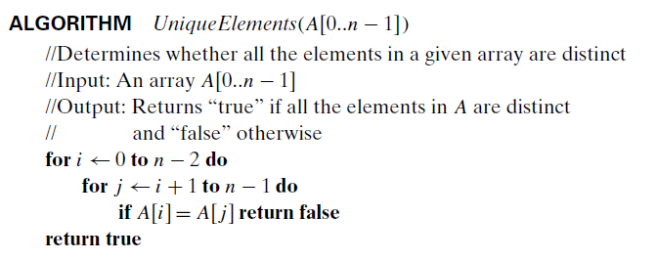

Ans i)__________________________

ii)_________________________

iii)_________________________

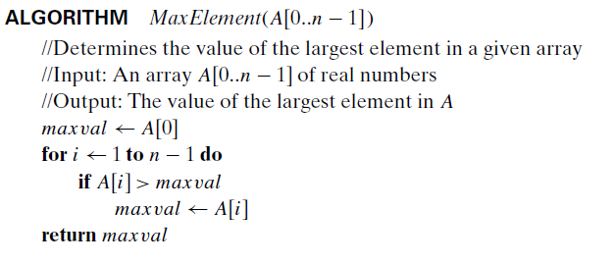

Ans i)__________________________

ii)_________________________

iii)_________________________

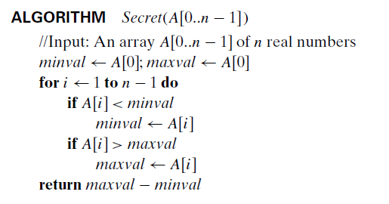

Ans i)__________________________

ii)_________________________

iii)_________________________